Intro to Prospect Research Webinar Details

Prospect research plays a strategic role in fundraising. This webinar will outline the basics of prospect research that can help your organization uncover funding opportunities within your donor base. During this webinar, attendees will learn how to identify individual prospects and build prospect profiles, how to access publicly-available wealth and philanthropic data, and best practices to consider when conducting and sharing prospect research. This session is perfect for people who are new prospect research or conduct research as part of their job, members of small development teams, and anyone interested in how prospect research works!

Presenters

Jessica Wade, Relationship Management Analyst, Science History Institute

Jessica joined the Science History Institute in 2013, when the Institute was known as the Chemical Heritage Foundation. As a member of the development team, Jessica is responsible for prospect research. Prior to the Institute, Jessica was an experience guide at the National Constitution Center. She also assisted with the creation of an online genealogical database while at the Historical Society of Pennsylvania. Jessica obtained an MA in history from Villanova University and a BA in history with minors in sociology and religious studies from Lynchburg College. She is a member of Apra and serves as co-chair of Apra’s 2021-2023 Membership Committee. She has served on the board of Apra Pennsylvania since 2018.

Lauren Woodring, Director of Prospect Research and Management, Philadelphia Museum of Art

Lauren started at the museum as a Research Analyst in 2017 and took on her current role in 2021. Previously, she was the Coordinator of Research and Development Systems at the Kimmel Center for Performing Arts. She holds a B.A. in History and Political Science from Lebanon Valley College, a M.A. in History from La Salle University, and a MLitt in Museum Studies from St Andrews University. She has been on the board of Apra PA since 2018 and currently serves as President. Additionally, she is the co-chair of the Prospect Development Best Practices Committee for AASP. She enjoys reading, Philadelphia sports, gardening, cooking, knitting, and hanging out with her cat.

Photos on next page

Photo of Jessica Wade:

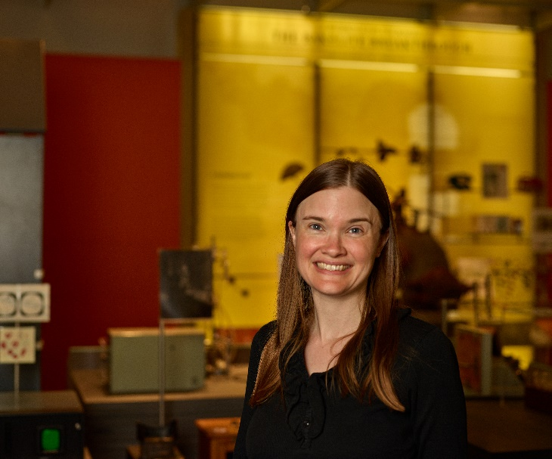

Photo of Lauren Woodring:



